Pharmacological Evaluation of concept of Tikta, Kashaya Rasa; Laghu, Ruksha Guna of Berberis aristata DC. and Tikta Rasa; Laghu, Snigdha Guna of Cedrus deodara (Roxb.) Loud. on Human Colon Cancer Cell Line COLO-205: An invitro study showing Role of Rasa-Guna Attributes in Cytotoxicity.
Abstract
Introduction: Ayurvedic pharmacology attributes therapeutic effects to Rasa (taste) and Guna (qualities), yet their mechanistic basis in cancer remains underexplored. This study investigates how Tikta, Kashaya Rasa and Laghu, Ruksha Guna of Berberis aristata DC. and Tikta Rasa; Laghu, Snigdha Guna of Cedrus deodara (Roxb.) Loud. have its activities as anticancerous in Human Colon Cancer Cell Line COLO-205. Materials and Methods: The Plant were collected, authenticated, Dried, Powdered and aqueous extract were prepared. COLO-205 cells were treated with aqueous extracts of Daruharidra and Devdaru at 10, 20, 40 and 80 µg/mL for 48 hours. Cytotoxicity was assessed via SRB assay, with Adriamycin as a positive control. Data were analyzed using one-way ANOVA (GraphPad Prism). Results: Berberis aristata DC. (Daruharidra) exhibited significant dose-dependent cytotoxicity, reducing viability to 59.3% at 80 µg/mL (p<0.0001), while Cedrus deodara (Daruharidra) showed minimal effect (>70% viability, p = 0.0065). Daruharidra’s Ruksha Guna correlated with stronger apoptotic induction, whereas Devdaru’s Snigdha Guna attenuated for cytotoxicity activity. ADR confirmed assay validity (<10% viability). Conclusion: Berberis aristata’s Laghu, Ruksha properties align with its Lekhana (scraping) action, enhancing cytotoxicity, while Cedrus deodara’s Snigdha Guna may protect cells for COLO-205 Cell Line. This study validates Ayurvedic Rasa-Guna principles in vitro, positioning Daruharidra as a promising candidate for further oncological research. Integrating traditional descriptors with modern assays offers a novel framework for phytopharmacology.
Keywords: Ayurveda, Cancer, Berberis aristata, Cedrus deodara, SRB assay.

1.INTRODUCTION
1.1 Basics of Rasa, Guna and Cell Lines
The ancient science of Ayurveda provides a deeply holistic understanding of health and disease, guided by the principles of Rasa (taste), Guna (qualities), Virya (potency) and Vipaka (post-digestive effect). Among these, Rasa and Guna play a pivotal role in modulating the activities in invitro study. Rasa is a knowledge that is felt through the Rasanā Indriya, which is located at Jihvā (tongue). Each and every Dravya in this world is composed of combination of different Guna in which they vary in their potency. Rasa can indicate the possible pharmacological actions of a substance. Tikta (bitter) and Kashaya (astringent) Rasa are traditionally attributed with Pitta-Kapha Shamaka properties, Ama Pachana, Medo Hara and Shodhana effects. The associated Gunas-Laghu (light) and Ruksha (dry)-facilitate deeper tissue penetration and metabolic correction, particularly useful in managing proliferative disorders. Berberis aristata DC. (Daruharidra), rich in these Rasas and Gunas, has been extensively documented in Ayurvedic texts like Charaka Samhita and Sushruta Samhita for its Shothahara (anti-inflammatory), Krimighna (antimicrobial) and Raktashodhaka (blood-purifying) actions, making it a candidate for oncological applications. On the other hand, Cedrus deodara (Roxb.) Loud., with its predominant Tikta Rasa but Laghu and Snigdha (unctuous) Gunas, offers a complementary pharmacodynamic profile. Its Vata-Kapha Shamaka properties, along with Lekhana (scraping) and Medohara actions, have been highlighted in Nighantus like Bhavaprakasha and Dhanvantari Nighantu. It is reputed for its Shothahara and Lekhana effects on abnormal tissue growth, aligning with current interest in its apoptotic and cytotoxic activities. This study explores the in vitro effects of Berberis aristata CD. (BA) and Cedrus deodara (Roxb.) Loud. (CD) on the human colon cancer cell line COLO-205, assessing their influence on cell viability, morphology and apoptotic induction. Colorectal cancer is one of the most prevalent and lethal cancers worldwide, accounting for more than 1 million new cases in 2008 and representing 8% of all cancer deaths. Cancer cell lines are valuable in vitro model systems that are widely used in cancer research and drug discovery. Under the right conditions and with appropriate controls, authenticated cancer cell lines retain most of the genetic properties of the cancer of origin. Compared to tissue samples, cell lines offer several benefits, such as a more uniform cell population, virtually unlimited supply and easy access to vast reference datasets like genome-wide DNA alterations, mutations and gene expression profiles. These cell lines originate from advanced cancerous tissues and do not model early-stage precancerous conditions like adenomas.

1.2 Aim
To Explain the Pharmacological activities of Dravyas through Rasa and Guna of Berberis aristata DC. and Cedrus deodara (Roxb.) Loud. on Behaviour of Human Colon Cancer Cell Line COLO-205.

1.3 Primary objectives
- To establish in vitro cell culture models using COLO-205 human colon cancer cell line for studying the anticancer effect of Berberis aristata DC. and Cedrus deodara (Roxb.) Loud.
- To evaluate and compare the pharmacological effects of the Rasa and Guna of Berberis aristata DC. and Cedrus deodara (Roxb.) Loud. on the growth behavior and morphology COLO-205 cells.

1.4 Secondary objective
- To determine and report the comparative activities of Berberis aristata DC. and Cedrus deodara (Roxb.) Loud. extracts on COLO-205 cancer cell line to assess their relative cytotoxic potential.
2.MATERIAL AND METHODS
2.1. Selection and Preparation of Drug Samples:
The drugs having Katu, Tikta, Kashaya Rasa and Ushna Guna have potential activities as over the cancer. Accordingly, The Plants Daruharidra and Devdaru were collected from Bagmati Provience, Kathmandu Valley, Lat:27.7716° N, Long: 85.4688° E; Lat:27.5970 N, Long: 853826 E respectively. The authentication of BA was done in Department of Botany, University of Rajasthan, Jaipur, India and for CD authentication was done KATH, KTM, Nepal with RUBL 21622 and Collection Number 2 respectively. The Sample drugs were dried, powdered and extracted were prepared through aquoeus extraction preparation method and tested for their cytotoxicity against Human Colon cancer cell Line COLO-205, using the SRB assay.
2.2. Study design: This study is analytical and experimental type of study.
2.3.Study setting:
a. Postgraduate Department of Dravyaguna Vigyan Laboratory, NIA, Jaipur.
b. Advanced Centre for Treatment, Research and Education in Cancer (ACTREC),
Navi-Mumbai.
2.4. Experimental procedure for SRB assay:
Cell lines were cultured in medium with 10% FBS and 2 mM L-glutamine, then seeded at 5000 cells/well in 96-well plates (100 µL/well). Plates were incubated at 37°C with 5% CO₂ and high humidity for 24 hours before drug treatment. Experimental drugs were initially solubilized at 100 mg/ml, diluted to 1 mg/ml in water and stored frozen. Before use, the 1 mg/ml stock was thawed and further diluted to working concentrations (100–800 µg/ml) in complete medium. Ten microliters of each dilution were added to wells containing 90 µl medium to achieve final drug concentrations of 10, 20, 40 and 80 µg/ml. After drug treatment, plates were incubated for 48 hours and then fixed with cold 30% TCA (final 10%) for 60 minutes at 4°C. Plates were washed and air dried before staining with 0.4% SRB in 1% acetic acid for 20 minutes. Excess dye was removed by washing with 1% acetic acid, followed by air drying. Bound dye was eluted with 10 mM Trizma base, and absorbance was measured at 540 nm (reference 690 nm).

2.5. Instruments & Equipments-
- 96-well microtiter plates
- CO₂ incubator
- Refrigerator/freezer.
- Micropipettes and tips
- Plate washer or manual pipetting system
- Microplate reader (spectrophotometer)
- Fume hood or biosafety cabinet (implied)
- Water bath or room temperature thawing station

2.6. Chemicals & Reagents-
- Fetal Bovine Serum (FBS) – 10% in culture medium.
- L-glutamine – 2 mM in culture medium.
- Experimental drugs/compounds
- Cold Trichloroacetic Acid (TCA)
- Sulforhodamine B (SRB) dye – 0.4% in 1% acetic acid.
- Trizma base (Tris-hydroxymethyl]aminomethane)
- Cell culture medium – complete medium containing FBS and L-glutamine.
- Sterile water – for drug dilution.
2.7. Experiment designing and evaluation of the anticytotoxic activity of the sample drugs
Three consecutive experiments were conducted using the Different dosages, and the results were tabulated.
  - COLO-205 Cell Line + differentiation media +ADR (Adriamycin)
  - COLO-205 Cell Line + differentiation media + Berberis aristata Conc-10 µg /ml
  - COLO-205 Cell Line + differentiation media + Berberis aristata Conc-20 µg /ml
  - COLO-205 Cell Line + Differentiation media + Berberis aristata Conc-40 µg /ml
  - COLO-205 Cell Line + Differentiation media + Berberis aristata Conc-80 µg /ml
  - COLO-205 Cell Line + Differentiation media + Cedrus deodara Conc-10 µg /ml
  - COLO-205 Cell Line + Differentiation media + Cedrus deodara Conc-20 µg /ml
  - COLO-205 Cell Line + Differentiation media + Cedrus deodara Conc-40 µg /ml
  - COLO-205 Cell Line + Differentiation media + Cedrus deodara Conc-80 µg /ml
  - COLO-205 Cell Line + Differentiation media
2.8. Statistical analysis
Experimental Data received from the Cell Line study of ADR, BA and CD were performed using Graphpad Prism Using One way ANOVA test followed by multiple comparisons test. P-value <0.05 considered as stastistically significance.
3. OBSERVATIONS AND RESULTS
3.1 Data Observations
The cytotoxic effects of BA, CD and ADR were evaluated on the human colon cancer cell line COLO-205 across a range of drug concentrations (10, 20, 40 and 80 µg/ml) using three independent experiments as shown in table 1. BA demonstrated moderate cytotoxicity with a gradual reduction in % control growth as the concentration increased. Average cell viability values declined from 78.6% at 10 µg/ml to 59.3% at 80 µg/ml, suggesting a dose-dependent response as shown in figure 1 and it is compared with the ADR and shown in figure 3. Although variability existed between replicates the consistent trend across all concentrations indicates that BA affects cell proliferation moderately, particularly at higher doses. In contrast, CD exhibited minimal cytotoxic activity. The average percent growth remained above 70% across all tested concentrations, with the highest being 89.4% at 40 µg/ml, suggesting only a slight inhibitory effect on COLO-205 cell viability as shown in figure 2 and figure 4 shows the comparison of CD with ADR . ADR (Adriamycin), a known chemotherapeutic agent, demonstrated strong cytotoxic activity even at the lowest concentration of 10 µg/ml. The average % growth across all concentrations remained below 10%, indicating near-complete inhibition of cell viability as shown in figure 3 and figure 4. These results validate ADR as a potent positive control and suggest that while BA shows moderate anticancer potential, CD is largely non-toxic and ADR is highly effective against COLO-205 cells at all tested doses.
3.2 Results of Cytotoxicity Assay
BA treatment showed a mean cell viability of 69.15 ± 4.228****, with an adjusted p-value <0.0001, signifying a statistically significant reduction in cell viability as given in table 2. CD treatment also led to a moderate reduction in cell viability (81.03 ± 3.952**) with a statistically significant adjusted p-value of 0.0065. ADR exhibited the most pronounced cytotoxic effect, with a mean viability of only 6.400 ± 1.142****, and a highly significant p-value (<0.0001) as shown in figure 5. Results from the COLO-205 cell line has no cytotoxicity for BA and CD as their GI₅₀ values are greater than 80 µg/ml and LC₅₀ and TGI values were not estimable (NE) as shown in table 3. In contrast, ADR (Adriamycin) showed significant cytotoxicity with a GI₅₀ of less than 10 µg/ml and a measurable TGI of 31 µg/ml, indicating potent anti-proliferative activity. Overall, the results suggest that BA and CD exhibit low cytotoxicity, as reflected by the high GI₅₀ values and minimal reduction in cell viability. ADR, however, demonstrates potent cytotoxicity, consistent with its known chemotherapeutic activity.

Table 1. Three independent experiments for Human Colon Cancer Cell Line COLO-205
Human Colon Cancer Cell Line COLO-205
% Control Growth
Drug Concentrations (µg/ml)
Drugs | Experiment 1 |  |  |  | Experiment 2 |  |  |  | Experiment 3 |  |  |  | Average Values
Drugs | 10 | 20 | 40 | 80 | 10 | 20 | 40 | 80 | 10 | 20 | 40 | 80 | 10 | 20 | 40 | 80
BA | 71.7 | 79.2 | 74.0 | 55.0 | 83.5 | 70.6 | 64.0 | 74.6 | 80.6 | 69.5 | 58.7 | 48.5 | 78.6 | 73.1 | 65.6 | 59.3
CD | 74.2 | 90.8 | 99.0 | 68.2 | 71.0 | 85.1 | 86.6 | 90.3 | 69.4 | 79.6 | 82.4 | 75.5 | 71.5 | 85.2 | 89.4 | 78.0
ADR | 5.3 | 5.1 | 8.5 | 8.9 | 0.1 | 9.6 | 10.1 | 8.5 | 3.8 | 8.0 | 6.0 | 2.6 | 3.1 | 7.6 | 8.2 | 6.7

Table 2: Stastistical significance values of the BA, CD and ADR for Human Colon Cancer Cell Line COLO-205.
Name of Human Colon Cancer Cell Lines | Berberis aristata DC. |  |  | Cedrus deodara (Roxb.) Loud |  |  | ADR
Name of Human Colon Cancer Cell Lines | Mean+SEM | Adjusted  P Value | SD | Mean+SEM | Adjusted  P Value | SD | Mean+SEM | Adjusted  P Value | SD
COLO-205 | 69.15+4.228**** | <0.0001 | 8.456 | 81.03+3.952** | 0.0065 | 15.83 | 6.400+  1.142**** | <0.0001 | 2.285

Table 3: LC50, TGI and GI50 values of the Drug analysed by Drug concentrations (µg/ml) calculated from graph

COLO-205 | Drug concentrations (µg/ml) calculated from graph
Drugs | LC50 | TGI | GI50*
Berberis aristata DC. | NE | NE | >80
Cedrus deodara (Roxb.) Loud. | NE | NE | >80
ADR | NE | 31 | <10

Figure 1: Effects of Berberis aristata DC. in Human Colon Cancer Cell Line Colo-205
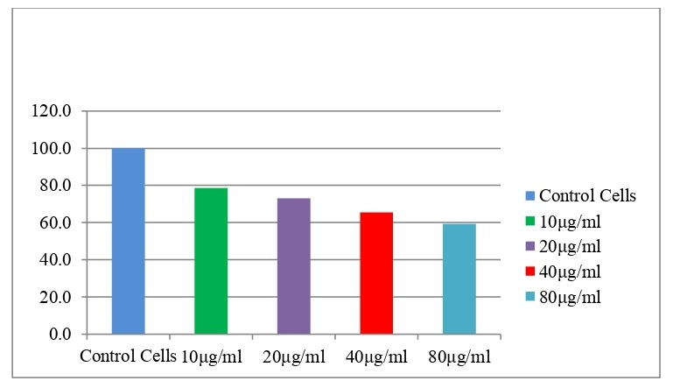
Figure 2: Effects of Cedrus deodara (Roxb.) Loud in Human Colon Cancer Cell Line Colo-205
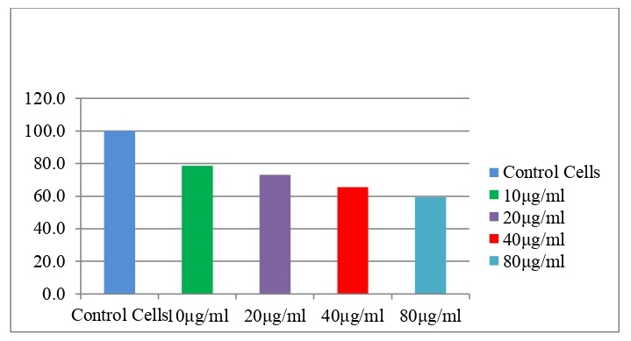

Figure 3: Effects of Berberis aristata DC.as shown in Growth Curve: Human Colon Cancer Cell Line Colo-205.
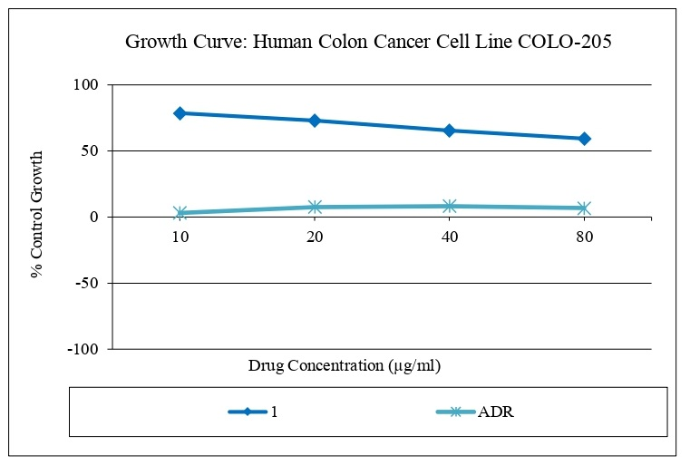
Figure 4: Effects of Cedrus deodara (Roxb.) Loud as shown in Growth Curve: Human Colon Cancer Cell Line Colo-205
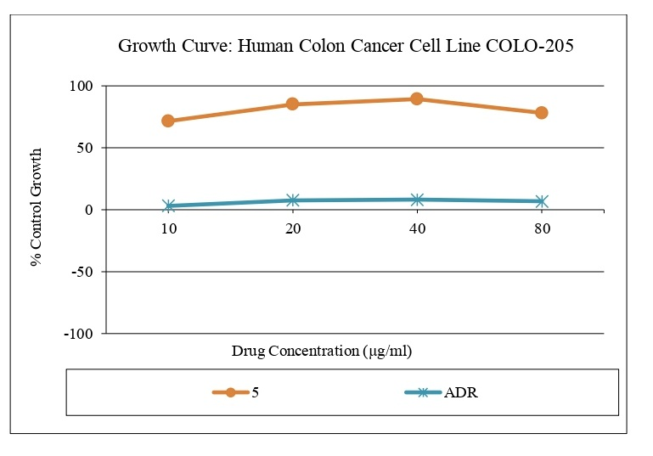

Figure 5: Dose-Dependent Cytotoxic Effects of Berberis aristata DC. and Cedrus deodara (Roxb.) Loud on COLO-205 Cell Viability with significance difference.
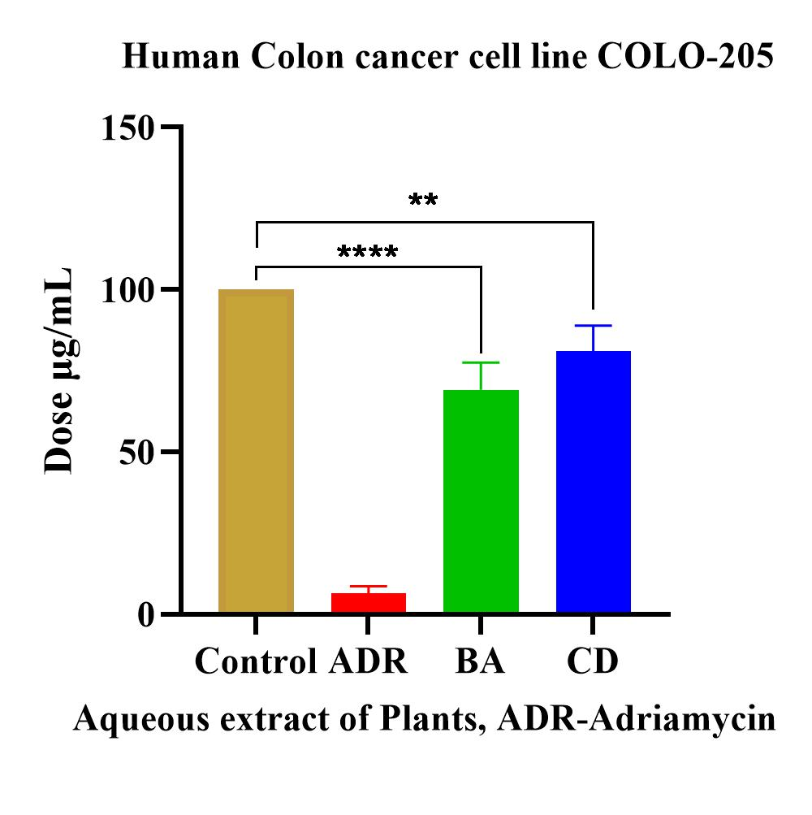
3.3: COLO-205 cell morphological observations: ADR, positive control exhibits severe cellular disruption, characterized by cell shrinkage, membrane blebbing and floating debris, indicative of apoptosis (Figure 6, A). Control shows a confluent monolayer of healthy, adherent cells with intact membranes and uniform morphology, confirming optimal growth conditions (Figure 6, B). In contrast, Berberis aristata DC. treatment displays intermediate effects: reduced cell density, partial rounding and detachment, consistent with moderate cytotoxicity (Figure 6, C). The presence of apoptotic bodies and irregular cell shapes suggests BA induces programmed cell death. Cedrus deodara (Roxb.) Loud reveals near-normal morphology with minor changes in cell density and adherence, reflecting its weak cytotoxic profile (Figure 6, D).
Figure.6. Bright Microscopic images of sample tested (High Drug Concentration used) on COLO-205 Cell Line
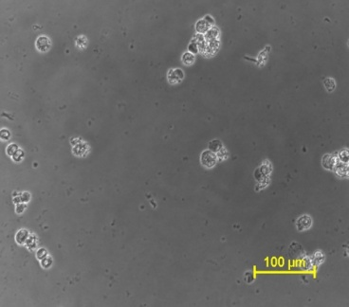 | 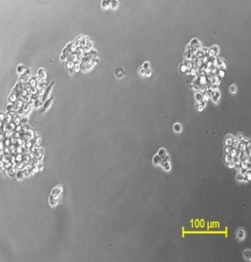 | 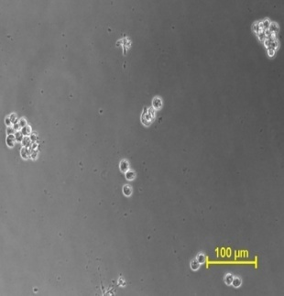 | 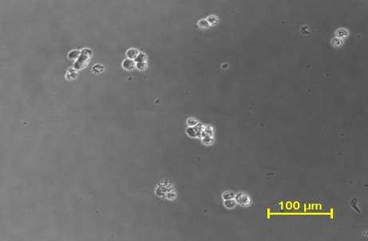
A.COLO-205 ADR | B.COLO-205 Control | C. Berberis aristata DC. (Daruharidra) | D. Cedrus deodara (Roxb.) Loud.(Deodaru)

Table 4: Rasa, Guna of the Selected Dravyas with their Dosha Karma and Karma.
S.No. | Dravyas | Rasa | Guna | Doshaj Karma | Karma
1. | Daruharidra⁵ | Tikta, Kashaya | Laghu, Ruksha | Kaphapitta Samaka | Dipana, RaktaShodhaka, Vrana Shodhaka
2. | Deodaru⁶ | Tikta | Laghu, Snigdha | Kaphavata Shamaka | Vrana Sodhaka, Dipana, Pachana, Lekhana

3.4 Comparison of BA and CD extract showing the Anticancerous activity in Human Colon Cancer Cell Line COLO-205.
From Experiment 1 (Table 1), BA demonstrated a gradual dose-dependent decrease in cell viability, especially notable at 80 µg/ml (55.0%). CD showed higher % growth across all concentrations, peaking at 99.0% at 40 µg/ml, indicating minimal cytotoxicity. From Experiment 2, BA again showed better cytotoxic response, especially at 40 µg/ml (64.0%). CD values remained consistently high (>85%) at all concentrations except 10 µg/ml, confirming lower toxicity. From Experiment 3, BA’s values significantly dropped with increasing dose, showing strong dose-dependent inhibition (lowest at 48.5% at 80 µg/ml). CD remained mostly above 75%, again reflecting lower cytotoxicity. The cytotoxic response of BA and CD on the COLO-205 cell line was evaluated through three independent experiments, each showing consistent trends. BA demonstrated a clear dose-dependent reduction in cell viability, particularly prominent at higher concentrations (40 and 80 µg/ml). For example, in Experiment 3, the % control growth dropped from 80.6% at 10 µg/ml to 48.5% at 80 µg/ml. This pattern reflects BA’s moderate but reproducible cytotoxic effect, which was evident across all replicates. In contrast, CD showed minimal effect on cell viability, maintaining high % growth across all doses and experiments, with values often exceeding 85%, suggesting poor anticancer efficacy in this cell line. When comparing the average values across experiments, BA consistently outperformed CD in reducing cancer cell proliferation, with an average viability of 59.3% at 80 µg/ml compared to CD’s 78.0%. Moreover, statistical analysis confirms this distinction: BA’s results were highly significant (p < 0.0001) with tighter consistency (lower SD), whereas CD had higher variability and weaker significance (p = 0.0065). These findings collectively indicate that BA possesses stronger and more consistent anticancer activity than CD, making it a more promising candidate for further investigation in colon cancer therapeutics.
4. DISCUSSION
This study aimed to assess the Tikta, Kashaya Rasa; Laghu, Ruksha Guna of Berberis aristata DC. (Daruharidra) and Tikta Rasa; Laghu, Snigdha Guna of Cedrus deodara (Roxb.) Loud. (Deodaru) using a cell line-based model.
4.1. Rasa and Guna and its analysis of selected Plants.
Each Rasa indicates a distinct Mahābhautika status of the substance. Although five Mahābhūtas can generate much more than six couplets of Utkarshata. The permutation and combination of the Mahabhutas varies and the one state of Rasas changes to the other one. From this concept there are formation of six primary Rasas viz. Madhura (sweet), Amla (sour), Lavaṇa (salty), Kaṭu (hot), Tikta (bitter) and Kaṣaya (astringent). Vayu and Akash Mahabhuta combination express it as the Tikta Rasa Vayu and Prithivi Mahabhutas combination shows the expression of the Kashaya Rasa. The Rasa as a molecules recognition process is a dynamic action, in which the Rasayanendriyas has a specific receptors for the oscillation of the specific Mahabhutas. To help for this kind of oscillation, there are three Mahabhutas which have the specific role to express the clear taste sensation. If Tikta Rasa is present in a drug and applied to the COLO-205 cell line, it may lead to a reduction in Rasa (plasma), Rakta (blood), Meda (fat), and Majja (marrow) components within the cells. Kashaya Rasa (astringent taste) Dravya aggravates Vata. When applied to the COLO-205 cell line, Kashaya Rasa may cause degeneration of bodily tissues, shrinkage of the cells, and a reduction in cell size. In our study, anticancer plant drugs were scored for their prevalence in terms of two Rasas, three important Guna as shown in table 4. Laghu Guna is the quality responsible for imparting lightness to a substance. It is composed of the bhoutika sanghatana of Agni, Vayu and Akasha Mahabhuta. Functionally, it exhibits Vatakara (aggravates Vata) and Kaphahara (alleviates Kapha) actions. It contributes to Dhatu Kshaya (depletion of body tissues) and Mala Kshaya (reduction of waste products). Other associated actions include Langhana (lightening therapy), Pathya (wholesome), Anupalepa (non-greasy), and Lekhana (scraping). Ruksha Guna is the quality that facilitates drying and is primarily composed of the bhoutika sanghatana of Vayu and Agni elements. It exhibits Kaphahara (alleviates Kapha) and Vatakara (aggravates Vata) actions. Ruksha Guna leads to Dhatu Kshaya (depletion of tissues) and acts on excretory products as Mala Shosaka (absorbs waste), Sthambhaka (obstructive) and Shosana (drying). Snigdha Guna is the quality that imparts unctuousness or oiliness to substances and the body. It is composed predominantly of the elements Jala (water) and Prithvi (earth). This guna exerts Vatahara (alleviates Vata) and Kaphakara (increases Kapha) actions. It supports Dhatu Vardhana (nourishment and enhancement of bodily tissues) and promotes Mala Pravartana (smooth elimination of waste). From the selected plants have the Bitter (Tikta) molecules such as Berberine, Oxyacanthine, Palmatine, Pakistanine, Jatrorrhizine, (+/-)-Karachine of Berberis aristata DC and Allohimachalol, Deodarine, Cedeodarin, Dihydromyricetin, beta-Sitosterol-beta-D-glucoside of Cedrus deodara (Roxb.) Loud. having bitter taste with different intensity.
4.2. Tikta (Bitter) and Kashaya Rasa (Astringent), Laghu (Lightnenss), Ruksha (Dryness) and Snigdha Guna (Unctuous) having anticancerous activity
Bitter compounds have health benefits, such as chemo-protection and reduced cancer risk. The anti-cancer effects of bitter taste receptor activation include the impact on apoptosis, proliferation, migration, invasion, viability, cycle cell arrest and stemness of cancer cells and the influence on tumor growth. For Daruharidra, It have molecular components as Berberine, Oxyacanthine, Palmatine significantly Inhibited cell proliferation and induced apoptosis in colon cancer cancer cells. BA possesses Tikta (bitter) and Kashaya (astringent) Rasa, along with Laghu (light) and Ruksha (dry) Guna, which contribute to its Deepana (appetizer) and Pachana (digestive) properties for the cells. Tikta rasa is known for its Lekhana (scarifying) effect, promoting the reduction of adipose tissue within cells. Kashaya rasa supports the depletion of all dhatus and also contributes to slimming. Both Daruharidra and Deodaru share Tikta rasa as a common feature; however, BA exhibits a more pronounced Kashaya rasa, which may account for its greater efficacy in reducing cell proliferation and inducing apoptosis in COLO-205 human colon cancer cells. Laghu Guna is present in both BA and CD. It is composed of Vayu and Agni Mahabhutas and exhibits actions such as Lekhana (scarifying) and Ropana (healing) at the cellular level. Ruksha Guna is especially prominent in BA. Formed by Vayu and Agni Mahabhutas, it possesses Shoshana Shakti (drying property), which facilitates the removal of excessive moisture from the cells. On the other hand, Snigdha Guna is uniquely present in CD. Derived from Jala and Prithivi Mahabhutas, it is characterized by Kledana Shakti (moistening property). Snigdha Guna imparts Sneha (unctuousness) and Mardava (softness), which are essential for maintaining cellular cohesion and function as binding forces between cellular components. From these Rasapanchaka principle of Ayurveda, Tikta, Kashaya Rasa; Laghu, Ruksha Guna of Berberis aristata DC. (Daruharidra) have more potency for the apptosis of the cell than Cedrus deodara (Roxb.) (Devdaru) having Tikta Rasa; Laghu, Snigdha Guna. Due to Laghu, Ruksha Guna Dravya BA, further clinical study will be need to say that it have anticancerous properties on the basis of these result observed as showing significant for anticancerous activities as compared to CD. Due to its enriched content of alkaloids such as berberine, oxyacanthine, berbamine, palmatine, jatrorrhizine, and columbamine BA has been reported to possess antioxidant, anticarcinogenic, and antidiabetic properties. Taking the present result into consideration, Snigdha Guna in CD it is possible to say that Dravya i.e. The cell apoptosis is reduced in COLO-205 cell line. According to our study report, Berberis aristata DC. shows significant anticancer activity on COLO-205 cell line than Cedrus deodara (Roxb.) Loud. As COLO-205 cells originate from metastatic colorectal carcinoma, is mature malignant cells. They lack the phenotypic and molecular characteristics of early adenomatous transformation, limiting their utility in modeling premalignant colorectal stages. The drug samples as Daruharidra and Deodaru have more potency over the premalignant colorectal cancer. BA and CD extracts exhibited dose-dependent cytotoxicity with higher doses showing enhanced anticarcinogenic effects. Significant cytotoxic activity was also observed at standard doses in mature Human colon cancer cell line COLO-205.
5. CONCLUSION
In this study, data were analyzed using one-way ANOVA followed by comparison tests. The results of the SRB assay demonstrated a significant increase in apoptosis in COLO-205 colon cancer cells following treatment with BA, while CD extracts showed a moderate apoptotic effect at higher concentrations. Experimental observations confirmed the biological activity of both BA and CD extracts at concentrations of 10, 20, 40 and 80 µg/mL in the COLO-205 cell line. Notably, BA exhibited cytotoxic effects at increasing with higher concentrations. In contrast, the cytotoxic potential of CD at elevated concentrations shows less activities againse COLO-205 cell line. This study also highlights the relevance of integrating Ayurvedic principles such as Rasa (taste) and Guna (qualities) including Katu, Tikta and Kashaya Rasa and Ruksha, Laghu and Snigdha Guna-within the framework with experimental study. These properties may be further explored and validated through advanced experimental methodologies to differentiate and quantify the pharmacodynamic effects of Rasa and Guna of Dravyas. The convergence of classical Ayurvedic science and modern biochemistry offers a promising avenue for advancing evidence-based validation of traditional medicinal concepts.

REFERENCES

Acharya YT. Dravyaguna Vijnananam. 7th ed., Vol. I. Shri Baidyanath Ayurveda Bhavan Ltd.; Patna, 1983.
Acharya Vagbhata, Asthanga Hridaya, Sutrastana 1st chapter, Shloka No-14, Nirmala Hindi Commentary, edited by Dr. Bramhananda Tripathi, Delhi, Chaukhambha Sanskrit Pratisthana, Reprinted 2015.
Sharma PV. Dravyaguna Vijnana. Vol. I: Basic Concepts. Varanasi: Chaukhambha Bharati Academy; 2013.pg 24.
Sharma SP, editor. Ashtangasamgraha, Sutrasthana 17/31. Varanasi: Chaukhamba Sanskrit Series Office; 4th reprint. p. 142-44.
Chunekar KC. Bhavprakash Nighantu (Indian Materia Medica). Pandey GS, editor. Varanasi: Chaukhambha Bharati Academy; 2018. p. 115.
Chunekar KC. Bhavprakash Nighantu (Indian Materia Medica). Pandey GS, editor. Varanasi: Chaukhambha Bharati Academy; 2018. p. 187
Ferlay J, Shin H-R, Bray F, Forman D, Mathers C, Parkin DM. Estimates of worldwide burden of cancer in 2008: GLOBOCAN 2008. Int J Cancer 2010;127: 2893-917
Masters J.R.W. Human cancer cell lines: Fact and fantasy. Nat. Rev. Mol. Cell Biol. 2000;1:233–236. doi: 10.1038/35043102. [DOI] [PubMed] [Google Scholar][Ref list]
Wu C-C, Hsu C-W, Chen C-D, Yu C-J, Chang K-P, Tai D-I, et al. Candidate serological biomarkers for cancer identified from the secretomes of 23 cancer cell lines and the human protein atlas. Mol Cell Proteomics 2010;9:1100-17.
de Wit M, Fijneman RJA, Verheul HMW, Meijer GA, Jimenez CR. Proteomics in colorectal cancer translational research: Biomarker discovery for clinical applications. ‘Clin Biochem’. 2013 Apr;46(6):466–79.
Sharma PV. Dravyaguna Vijnana. Vol. I: Basic Concepts. Varanasi: Chaukhambha Bharati Academy; 2013.pg 9.
Vagbhata. ‘Ashtanga Hridaya’, Sutrasthana, Chapter 1, Shloka 14. In: Tripathi B, editor. ‘Nirmala Hindi Commentary’. Delhi: Chaukhambha Sanskrit Pratishthan; 2015. Reprint ed.
Hegde PL, Harini A. ‘A Text Book of Dravyaguna Vijnana’. Vol. 1. New Delhi: Chaukhambha Publications; 2023. p. 108.
Shallenberger RS, Acree TE, Guild WE. Taste of dilute solutions: a classification based on the molecular structure of compounds. J Food Sci. 1955;30:560.
Singh RH. An assessment of the ayurvedic concept of cancer and a new paradigm of anticancer treatment in Ayurveda. J Altern Complement Med. 2002 Oct;8(5):609-14. doi: 10.1089/107555302320825129. PMID: 12470442.
Dhyani SC. ‘Dravyaguna Siddhanta’ [Principles of Dravyaguna]. Varanasi: Chaukhambha Krishnadas Academy; 2022. (Sanskrit & Hindi).
Acharya YT, editor. Caraka Samhita with Ayurveda Dipika Commentary of Chakrapani Dutta. New Delhi' Rashtriya Samskrita Samsthan; Vol 1, 2006.
Vagbhata. ‘Ashtanga Hridaya’, Sutrasthana, Chapter 1, Shloka 14. In: Tripathi B, editor. ‘Nirmala Hindi Commentary’. Reprint ed. Delhi: Chaukhambha Sanskrit Pratisthana; 2015.
Paudel K, Ramamurthy A, Sharma G. Preliminary pharmacognostical and phytochemical study of the stem bark of ‘Berberis aristata DC. AYUHOM. 2023;10(1):7–13. doi:10.4103/AYUHOM.AYUHOM\_32\_22.
Bisht A, Jain S, Misra A, Dwivedi J, Paliwal S, Sharma S. Cedrus deodara (Roxb. ex D.Don) G.Don: A review of traditional use, phytochemical composition and pharmacology. J Ethnopharmacol. 2021 Oct 28;279:114361. doi: 10.1016/j.jep.2021.114361. Epub 2021 Jun 22. PMID: 34166738.
Zehentner S, Reiner AT, Grimm C, Somoza V. The Role of Bitter Taste Receptors in Cancer: A Systematic Review. Cancers (Basel). 2021 Nov 23;13(23):5891. doi: 10.3390/cancers13235891. PMID: 34885005; PMCID: PMC8656863.
Wu K, Yang Q, Mu Y, Zhou L, Liu Y, Zhou Q, He B. Berberine inhibits the proliferation of colon cancer cells by inactivating Wnt/β-catenin signaling. Int J Oncol. 2012 Jul;41(1):292-8. doi: 10.3892/ijo.2012.1423. Epub 2012 Apr 2. PMID: 22469784.
Cao H, Song S, Zhang H, Zhang Y, Qu R, Yang B, Jing Y, Hu T, Yan F, Wang B. Chemopreventive effects of berberine on intestinal tumor development in Apcmin/+ mice. BMC Gastroenterol. 2013 Nov 27;13:163. doi: 10. 1186/1471-230X-13-163. PMID: 24279644; PMCID: PMC4222594.

