Role of Agnikarma in the management of Apabahuka - A Case Report

Author – Dr. Sangita Verma
Assistant Professor
Department of PG studies in Shalyatantra
SGM Ayurvedic College Gazipur

Abstract: Apabahuka is a Vataja Nanatmaja Vyadhi in which locomotive functions of Amsa Sandhi are affected mainly due to vata dosha prakopa causing Pain, Stiffness and Restricted movement of the shoulder. Apabahuka can be correlated to Frozen Shoulder or Adhesive capsulitis in modern medicine because of similar Symptomatology. A male patient of age 52yrs approached Ayurved Hospital with pain restricted movements and stiffness in both Shoulder for 6 months and diagnosed as Apabahuka. This is a disease that highly hampers one’s way of living by causing hindrance of personal and professional life both. So, there is a need to find immediate relief as well as long lasting effective treatment for the patient. The patient was subjected to the Agnikarma along with Shamana yoga. After the treatment, the stiffness of the joint was reduced. The patient got moderate relief from the pain.
Introduction: It is caused mainly by the Vyana Vata vitiation and gets Sthana Samshraya in the Amsa Pradesha. There it does the Shoshana of Shleshaka kapha, Mamsa, sira, snayu leading to Bahupraspanditaharatwam (restricted movement of affected shoulder), Shoola (Pain), Stambha (stiffness). These clinical features closely resemble with painful stiffness and loss of motion of shoulder. Hence it can be correlated with Frozen Shoulder. In general population prevalence rate is about 3%-5% and up to 20% in those with diabetes. It is peak between the ages of 40-60 years and is more common in women. In allied science treatment modalities like analgesics, local intra articular injections of corticosteroids in glenohumeral joint followed by physiotherapy are adopted.
Agnikarma is one among the para-surgical procedures. Agnikarma is indicated for Twacha, Mamsa, Sira, Snayu, Asthi and Sandhigata vyadhis. Agni being Ushna act against the qualities of Vata and Kapha dosha hence cures all Vataj and Kaphaj disorders. Agnikarma was carried out with the help of Panchaloha Shalaka. Panchaloha was made up of Tamra, Loha, Yashada, Rajatha, Vanga in 4:3:1:1:1 ratio. As Shamana yoga we gave him Vishamustyadi Vati mainly indicated in Pakshaghata, Gridrasi, Vishama jwara, Snatugata Vikara. Detailed explanation of Vishamustyadi vati is available in the textbook named Ayurved Sara Sangraha. Ingredients of Vishamustyadi vati are Kupilu, Indravaruni, Maricha and Eranda.
Objectives: To study the effect of Agnikarma along with Shamana yoga in relieving symptoms of Apabahuka.
Case Study: A male patient age 52 years approached the Ayurved hospital. He had pain, stiffness and restricted movement of both Shoulder for 6 months. No history of any external trauma to the affected part. No any relevant surgical or medical history. The patient had mild pain in the initial stage and gradually developed stiffness and severity in pain intensity. Shoulder movements become restricted, and the patient develops difficulty in raising the both shoulder. Even after taking painkillers, the patient continued with the same complaints which made him worried about his condition.
Samanya Pareeksha: The patient was well built, ill look was there on his face because of the pain. Gait was normal. His weight was 69kg and other parameters are under normal limits.
Astha sthana Pariksha:
Nadi: 80bpm
Mutra: Pravrutti- Samyak Pravartana 5-6 times a day and 1 time in night.
Mala: Pravrutti- Samyak Pravartana 1 time a day
Shabda: Prakruta
Sparsha: Ushnasheeta
Druk: Prakrita
Akriti: Uttama
Srotas Pariksha:
Annavaha Srotas: Agnimandaya
Mamsavaha Srotas: Stambha of Dakshina Bahu
Asthivaha Srotas: Shoola in Dakshina Bahu
Nidana Panchaka:
Hetu: Jaravastha, Avyayama, Rooksha ahara seven
Poorva Roopa: Alpa Vedana in Dakshina Amsa Sandhi
Roopa: Dakshina Amsasandhi shola, stambha and bahupraspanditahara
Samprapti Ghataka:
Dosha: Vata and Kapha
Dushya: Mamsa, Medha, Asthi, Majja
Sroto Dushti: Sanga
Udbhvava Sthana: Pakvashaya
Vyakta Sthana: Amsa sandhi
Sadhyasaadyata: Krachha Sadhya
Vyadhi vyavachhedhana: Apabahuka, Vishwachi, Manyastambha
Examination of Shoulder Joint:
Inspection:
Discoloration: Absent
Muscle Wasting: Absent
Deformity: Absent
Palpation: Stiffness present at both Shoulder joint,
Temperature: Absent
Restriction of movements: Present up to 40 degrees
Investigation: X-ray – no abnormality detected.
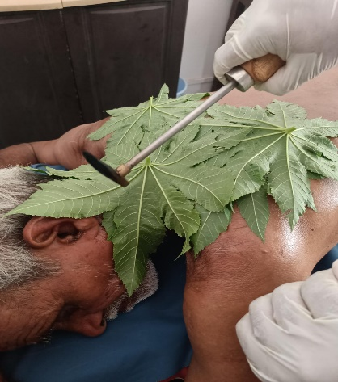
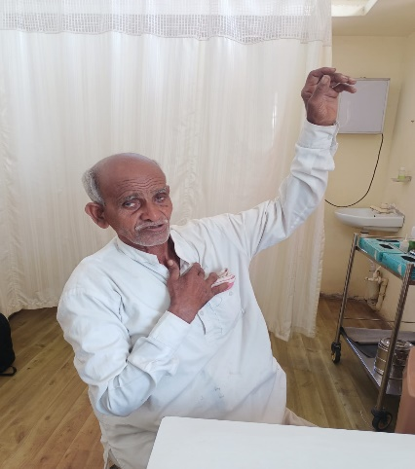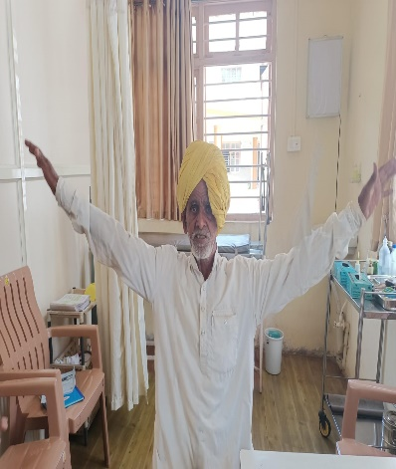
Fig:1 Before treatment Fig:2 During Procedure Fig: 3 After treatment

Materials and methods:
Sources of Data:
Literary Source: The literary data was collected from classical Ayurvedic and modern textbooks and updated with recent medical journals and internet sources.
Clinical Sources: Patient was approached to ayurved hospital.
Method of Sampling and Study design: Simple randomized Single Case Study.
Interventions: It was a single case study of Agnikarma with Panchaloha Shalaka
Poorva Karma:
- Informed written consent was taken.
- Patients was taken in Comfortable position.
- Abhyanga was carried over shoulder region.
- The most tender point was marked with a marker.
Pradhana Karma:
- Tip of the Panchaloha Shalaka was heated to red hot and applied to the marked area.
- Duration of Agnikarma was 15 minutes.
Paschat Karma:
- Ghritakumari pulp was applied on the site of Agnikarma to relieve burning pain.

Result:
Effect of treatment on Pain:
In Apabahuka pain is felt due to vata prakopa caused by various nidanas. By doing Agnikarma and its poorva karma like sthanika abhyanga vata shamana occurs which reduces the pain.
Effect of treatment on Stiffness:
Stiffness occurs due to sira sankocha and sleshaka kapha kshaya there by producing Bahupraspandithara: by doing Agnikarma and its poorva karma reduces the pain.
After the treatment range of movement increased, showing extremely significant result in Flexion, Extension, Abduction,
Adduction, Internal rotation which were assessed using Goniometric measurements.

Discussion
The present day lifestyle which is full of physical stress and strain has led to the development of diseases which may not kill the person but hampers the daily routine activities and impair the quality of life. Apabahuka is one such disease in which vata dosha dushti occurs which gets localized at Amsa Pradesha. This Vata Dushti does Sira Sankocha and Sleshaka Kapha thereby producing Bahupraspanditahara (restricted movement of bahu) and Amsa Sandhi Shoola. Acharya have not mentioned specific nidanas for Apabahuka. But since it is a Vataja Nanatmaja Vikara. Vata is invariably involved. Hence the Nidanas which are mentioned for Vata Vyadhi are to be considered as Nidanas for Apabahuka. Apart from those Nidanas, some Nidanas like indulging in certain incorrect postures while sitting or lying down, or while using gadgets such as computes/phone, carrying heavy weight on one side of the shoulder, swimming or any direct trauma, improper diet, continuous use of Ac/fan etc. are practically observed in patients. These Nidanas do Vata Prakopa in Amsa Pradesha which causes Sira Sankocha and Amsa Bandhana Shosha leading to Apabahuka. In the present study maximum patients belonged to the desk job group who admitted to indulging in improper sitting/sleeping postures were found to be having Apabahuka. Frozen Shoulder is disabling disease of shoulder and is self limiting, but recovery taken much longer time up to 3-4yrs. As the recovery periods very longer & initial stage of freezing is very painfull. Some alternative treatment like Ayurveda is very beneficial Agnikarma is very unique procedure described in Ayurveda for instant relief from pain. Agnikarma is mentioned in all painful condition which are due to Vata & Kapha. Frozen shoulder can be correlated with Apabahuka as per Ayurveda. Vata & Kapha both are involved in pathology of frozen shoulder. This gives immediate improvement in symptoms of frozen shoulder. In present case patient got 80% relief in pain on first day immediately after Agnikarma. As the pain was reduced patient was able to do gentle stretching excercised. This in present case we got excellent result by Agnikarma in pacification of Vata & Kapha there by give significant relief in symptoms.
Conclusion
Apabahuka vyadhi associated with Vata and Kapha dosha can easily manage or be treated with Ayurvedic treatment protocol. The treatment principle is based on the combined effect of heat and medicament. Proper selection of drugs and proper duration of the treatment will cure the disease.
References
- Acharya K.R.Shrikantha Murthy, Sharranghdhara Samhita, Purvardha, Chapter-7, Shloka no- 108 Choukambha Publication, Edition5, 2003, Page No-40.
- Acharya K.R.Shrikantha Murthy, Astanga Sangraha Nidana Sthana, Chapter-15, Shloka no-45, Choukambha Publication, Edition5,2005, Page no- 247.
- Chetan Agrawal, Rashmi Kale, Case Study of Frequent Leech application in Diabetes mellitus with special reference to Frozen Shoulder. Ayurlog: National Journal of Research in Ayurved Science-2018.
- Dr. Conception costa, Dr. Sudarshan A. A comparative clinical study on the efficacy of Nasya with Pinyaka/Panchamula Taila and Swalpa Masha Taila in Apabahuka w.s.r. to frozen shoulder.

