A Management of Bhagandara (fistula-in-ano) with Ksharasutra: A Case Study

Author – Dr. Ved Prakash Sharma
Assistant Professor
Department of PG studies in Shalyatantra
SGM Ayurvedic College and Hospital, Gazipur

Abstract
Fistula-in-ano is a chronic inflammatory condition having a tubular structure with opening in the Anorectal canal at one end and surface of perineum or perianal skin on the other end. Any opening in perianal area with chronic pus discharge indicates fistulous tract. Prolong sitting, unhygienic condition, obesity, repeated irritation due to hair may increase the risk of occurrence. In Ayurveda it is correlated with Bhagandara and Acharya Sushruta mentioned five types of Bhagandara. He had explained Shastra Karma along with Kshara karma and Bheshaja Chikitsa for treatment. Here a case of fistula in Ano in a 30-year male patient was examined in Shalya OPD and treated with Ksharasutra, considering it as an ideal procedure in treatment of Bhagandara as it cuts and curettes the unhealthy tissue present inside the fistulous tract.
Keywords: Bhagandara, Ksharakarma, ksharasutra
Introduction:
In Ayurveda it is mentioned that certain clinical condition requires surgical intervention for better cure. Charaka mainly a Kayachikitsa treatise also stated that the diseases like Gulma, Arsha, Bhagandara, Ashmari may require surgical intervention. Sushruta has discussed in the detail about various Shastra karma along with Anushastra karma which includes Agnikarma, Jalaukavcharana and Ksharakarma. Kshara is considered as one of the most important Parasurgical procedures as it can produce excision, incision, scrapping and can pacify all three Doshas.
Kshara application in the form of Ksharasutra, in anorectal diseases has become more popular due to its easy approach and low rate of recurrence. Ksharasutra induces both mechanical and chemical cutting and healing. Direct reference of Ksharasutra is found in Sushruta for treatment of Nadivrana. Chakradatta has referred to a medicated thread coated with Snuhi and Haridra powder in treatment of Arsha and Bhagandara. But the modified Ksharasutra available now a day is re-established by the Dept. of Shalya Tantra, Banaras Hindu University. The standard Ksharasutra is prepared by 11 coatings of Snuhi Ksheera then 7 coatings of Snuhi Ksheera and Apamarga Kshara and then again 3 coatings of Snuhi Ksheera and Haridra Churna.
In this case used Ksharasutra is prepared by 11 coatings of Arka Ksheera then 7 coatings of Arka Ksheera and Palasha Kshara and then again 3 coatings of Arka Ksheera and Haridra Churna. This Kshara Sutra is used in treatment of fistula in ano due to its cutting, curetting, and healing effect as well as it controls the infection.
In this study a case report of Fistula in Ano treated by Ksharasutra which was cured and no further complaints were found in the patient during follow up period.
Ayurvedic view of Bhagandara and Kshara Sutra
Acharya Sushruta described Fistula in Ano under the heading Bhagandara along with its symptoms, types, and its management. An abnormal passage between a hollow or tubular organ (Bhaga, Guda, or Basti) and the body surface or between two hollow or tubular organs is called fistula.
Kshara destroys the vitiated tissue and make them fall off. It is the most important among Shastra and Anushastra because it does functions like excision, cutting and scrapping, also mitigates all the three Doshas.
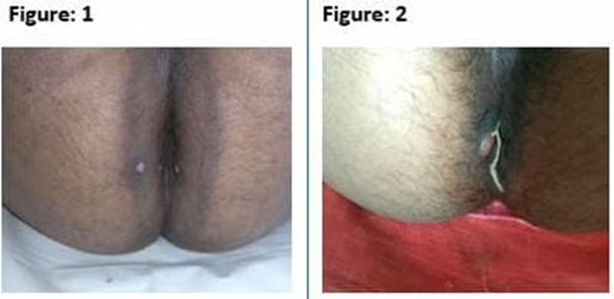
Case 1: Palashaksharasutra in situ before & during treatment of Bhagandara
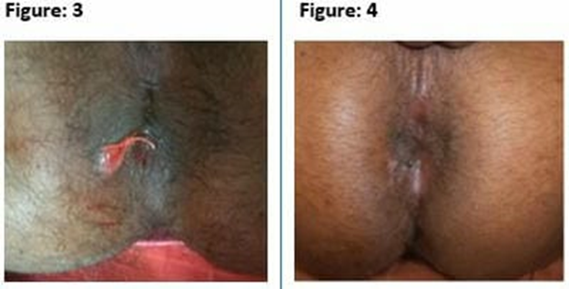
After cut through of Bhagandara by Palashaksharasutra

Case Report
Age - 45 year
Gender- Male
Occupation- Businessman
Chief complaints and duration
Patient complains of pus discharge with mild pain at the right side of perianal region in the last 6 months.
H/o present illness: Patient was apparently normal before 3 months. Then he had developed boil with intermittent discharge in perianal region since last 3 months. He also complained of mild pain and discomfort while sitting and continuous pus discharge in the last 1-2 months. He had taken analgesics for it, but didn’t get any relief.
Therefore, for further treatment he came to OPD of SGM Ayurvedic Hospital.
Family history: No H/O HTN, DM or any other major illness
General examination
G.C - Moderate Afebrile
CVS - S1 S2 Normal.
Pulse - 78/min
BP - 130/80 mm Hg
RS - Chest clears on both sides.
Digestive System
Appetite – normal
Bowel - constipated.
Uro-genital System - NAD
Local examination:
In lithotomy position of patient, the findings observed were, patient had hairy perineal region with a small opening in right side of perianal region with seropurulent pus discharge through that opening, tenderness on touch with indurations was felt around external opening. Probing was done from external opening to access the internal opening but internally it was fibrosed. About 5 cm tract was found during probing.
On proctoscopy examination no any anal pathology was seen. After complete examination the diagnosis was confirmed as Fisula in Ano i.e., Bhagandara.
In this patient perianal skin was normal with no dermatitis
Ksharsutra application
Pre-operative preparation: 5gm Panchasakar Churna with Luke warm water was given to the patient at night before operation. Proctoglycerin enema was given at early morning on day of operation. After proper bowel passed, patient was taken to recovery room and injection T.T. 0.5ml IM was given and plain xylocaine 2% was given subcutaneously for sensitivity test.
Operative procedure: Patient was taken in lithotomy position on operation theatre table.
After proper painting and draping, local anesthesia with 2% xylocaine was infiltrated nearby opening and around anal verge.
Reassessment of extension of tract was done by probing. Probe was removed through anal opening via internal opening after feeding of Ksharasutra and Ksharasutra ligated appropriately. Complete hemostasis was maintained and T bandaging was done.
Postoperative procedure: Ayurvedic medicines and sitz bath was given. Patient was admitted to the Hospital for 7 days till next Ksharasutra was changed
Oral medications
Triphala Guggulu TID
Gandhak Rasayan TID
Panchasakar Churna 5grams at night
Sitz bath with Triphala Kwath.
Patient was advised to take Khichdi and Daliya during hospital stay. He was also advised to resume his normal day to day activities.
Follow-up: Patient was discharged from hospital after 1st Ksharasutra change and then asked for changing Ksharasutra every 7th day till cutting of the tract. Warm water sitz bath and Jatyadi Taila local application was done during this period. Patient was allowed to do his routine job after discharged from hospital. After 6 sitting the tract was totally cut and healing was achieved simultaneously. Jatyadi Taila application on scar mark was advised.

Discussion
Acharya Sushruta described the treatment of fistula in ano as Bheshaj, Ksarakarma, Agnikarma and Shastra Karma.
A management of Bhagandara (fistula-in-ano) with Ksharasutra
In modern medicine treatment like fistulotomy, fistulectomy, seton ligation are indicated. These treatments have more recurrence rate and post-operative complications like hemorrhage, pain, delayed healing etc. In comparison to Modern Treatment Ksharasutra ligation is better due to its minimal complications and less recurrence. Even fecal incontinence and anal stricture are not seen in this case.

The application of Ksharasutra is having anti- inflammatory and anti-microbial property and due to its alkaline property helps in cutting and healing. Cutting mainly occurs due to local action of Kshara, Snuhi and the mechanical pressure of Ksharasutra knot. Haridra powder having antiseptic action helps in healing of the tract.

Conclusion

The incidence of fistula in ano is increasing now a day due to improper job style where a person sits for long time on hard surfaces. The management of anorectal diseases need a complete knowledge of anorectal anatomy and pathophysiology. Also, it needs to be diagnosed early so that appropriate treatment can be given without delay. Ksharasutra helps in removal of debridement and prevent from bacterial infections. Ksharasutra at a time provides both cutting and healing so we can use it in any type of fistula tract. So, we conclude that in fistula in ano Ksharasutra treatment is a better option due minimum complication and patient can resume normal activities earlier.

Reference
1. Vaidya Yadavji Trikamji Acharya, Sushruta Samhita, Nidan Sthan, Chaukhamba Publications, published 2020, Page no.213.
2. Vaidya Yadavji Trikamji Acharya, Sushruta Samhita, Chikitsa Sthan, Chaukhamba Publications, published 2020, Page no.213.
3. Kaviraj Ambika Dutta Shastri, Sushruta Samhita, Nidan Sthan, Chaukhamba Sanskrit Samsthan, Published 2019, Page no.155.
4. Kaviraj Ambika Dutta Shastri, Susruta Samhita, Chikitsa Sthan, Chaukhamba Sanskrit Samsthan, Published 2019, Page no.156.

